Design Thinking – Personal Reflection Essay

Submitted By:

Kishlay Kumar

**Course Overview**

The Design thinking course may have lasted for ten days only but feels like a much longer grind because of the roller coaster of emotions and experiences that I went through in the journey of this course. Right from first day I had certain beliefs regarding design and not a day has gone by in this class when my beliefs were not challenged. Learning from all the different perspectives offered by this course when trying to create a product from scratch has been an intellectually stimulating experience that I as an engineer have experienced and which I will describe in the following sections.

**Design a Bag**

* My first interaction with designing in this class was the activity where we decided to design a bag in teams of two. I started off by designing a bag that was a right fit according to me. The first design was more a representation of my needs and problems rather than my user’s. The second task where we got to talk to our partner and understand their needs is where I realised how different my needs are from the needs of my customer. Where I preferred a light bag which was handy and easy to carry and could trade off some space for that, my partner preferred a big and heavy bag which could carry all his stuff like toiletries, clothes, etc. I came up with a couple of radical ideas which looked more like a caricature rather than a real product (my poor drawing sales are partly to blame). But my partner found one of my designs interesting and suggested the same design but with certain changes would be something that he would be willing to buy for the right price. Another two rounds of redesigning and feedback followed and in the iterative process I ended up creating a product that was to my customer’s satisfaction.
* This activity exposed me to the process of navigating towards the solution rather than jumping to the conclusion. Every user is different, and we have our own prejudices when we start to design a solution which reflected on the first design that I built without talking to my partner at all. Documenting the needs of a user and revisiting them again and again while designing the product is a powerful tool that helps us keep ourselves aligned with the ultimate goal. When a design comes up keeping in mind the users need then the user also gets involved in the design process and this is something that I observed as I sketched some radical ideas with a pen and paper. To me those pictures looked like a mockery, but my partner found one of the designs interesting and we picked that specific prototype for further iterations to build upon before arriving at the final design.
* Personally, this exercise also made me realise the error of my ways that I had been committing while working in my previous company. In my eagerness to solve the technical issue, I used to lose track of the bigger picture. Procrastinating any kind of feedback on my code until the deadlines were close would land me in trouble at times as well. This exercise helped me re-evaluate my ways and realise the mistake I committed previously and which I hope to not repeat in the future.

**Understanding the User**

The process of understanding the user was a totally new experience for me that I thoroughly enjoyed as I got to look at the bigger picture for once. The following were the key takeaways from that exercise for me:

* Coming from an engineering background with an experience of almost two years as a Software Developer for a small unit of a multinational software company, I had become accustomed to looking at a problem from a very narrow perspective. I rarely ever tried to look at a problem in the larger context of the product. To me the solution to a particular issue was always in the code and not in the design. But this idea was challenged through this exercise. While I went into the class more concerned about the technical difficulties of the product that I wished to create, I came out of it with a better understanding of the need for the solution that I wished to arrive at.
* The 5 Why Approach and the 5 WH questions helped me appreciate the time that needs to be spent working in the problem space in order to identify the precise pain points and needs of the user before moving into the solution space.
* Also, as an engineer who barely managed to get through subjects like Engineering Drawing, I dreaded going back to any activity where my creativity would be tested through my drawing skills. But as we went through the class, I realised that design thinking is more about following a set of practices that yield the best results rather than about my artistic skills.
* My views on creativity which I felt was the task best left to creative minds was also challenged through the HBR article on Design Thinking by Tim Brown, which claims that creativity is great ideas are not just the creative genius of brilliant minds but rather a product of hard work augmented by creative human centered discovery process followed by iterative cycles of prototyping, testing, and refinement.
* Empathy is another important tool in the arsenal of person who wishes to design a product. And while I consider myself to be an empathetic individual in personal life, I realised how my actions in all professional settings that I had been a part of were completely contrary to that claim. Hence, I believe there is room for improvement for me in that regard.
* Another important thing that I realised in this class was the true definition of a prototype. Up until now I considered prototypes to be a rough version of final product without all the functionalities implemented. But through the class I learned that a prototype is anything that could be built with minimum effort and models the solution that we are trying to build. This could be something as simple as a pen and paper sketch/storyboard or a well-developed prototype developed using tools like Balsamic.

**User Interviews and Idea Generation**

This was another interesting phase of the class for me as we set out to define our final problem statement and talk to our potential customers. Here are the key takeaways from this exercise:

* The user interview exercise was another great exercise where we started off with writing down the questions for our potential users. As someone who had never experienced the process of user interviews, I was exposed to the process to how an interview is planned. TO my surprise, user interviews are not like the Q&A sessions that we watch on news channels. They are more a conversation between the two parties where one is trying to identify the needs of other through a natural and genuine conversation with the other. This process is much more difficult since we may not end up asking all the questions that we had prepared, and the conversation may end up moving in a direction that we had not originally intended. However, exploratory interviews are intended to gauge the situation in our problem space, validate certain hypothesis and gain new insights about things that we may not have never thought about. To identify the true pain points that could be help us identify a potential problem statement from these conversations is a skill that I would like to develop.

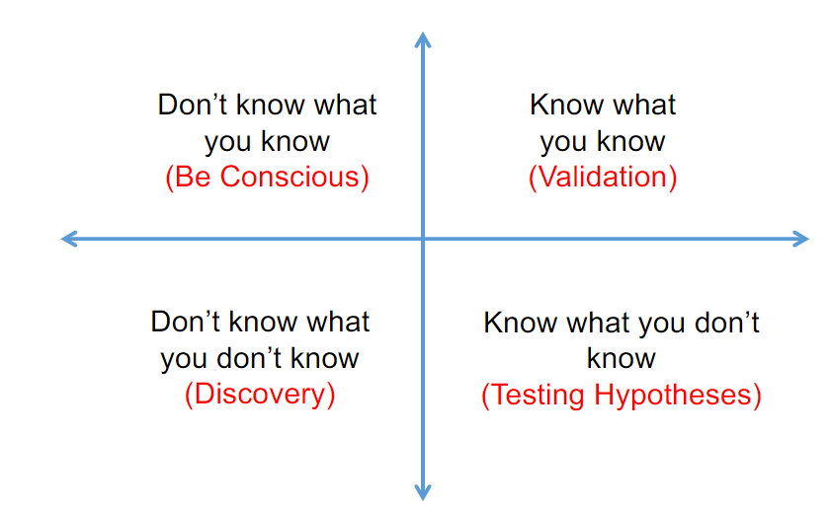

* I realised that defining a problem statement in a concise and well-established manner by being the problem space is a much more difficult task as compared to doing the same from the problem space. More often than not when trying to solve a problem we already have a solution in mind and thus we end up constraining ourselves to a problem statement that is too specific and fails to generalise to the changing user needs. But if take the bus from the other side we end up with a problem statement that is much clear, well-defined, and robust which can adapt to changing user needs since we decided to target a particular pain point rather than a solution.
* Learning about the different method of idea generation was useful especially methods like 6-3-5 and the Morphological Matrix. ME and my team ended up picking the morphological matrix approach for idea generation where we identified four different columns – and a set of 5-6 ideas under each column. This was a novel approach to generating hundreds of ideas in only a few minutes which could then later be refined into smaller subset that we would choose to work on.
* 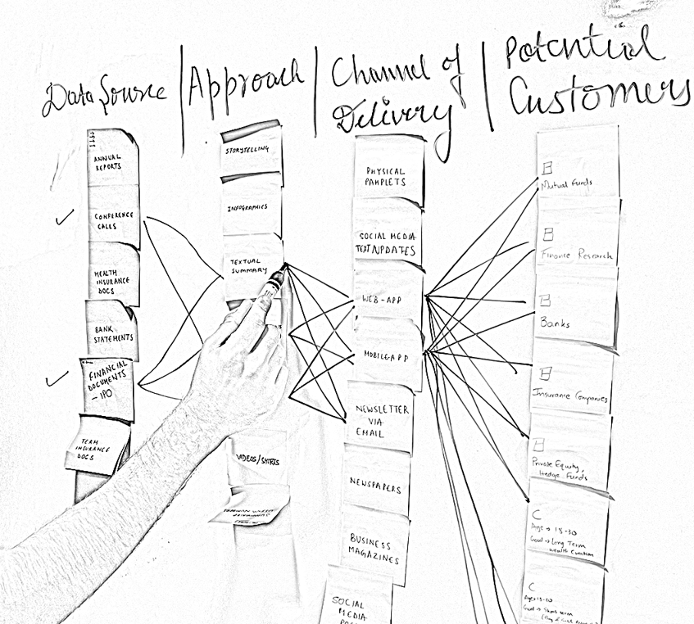Dividing the solution space into different sections helped us identify new ways of solving the problem. While our initial idea was to build an app or a website, the morphological matrix approach led to fresh and wild new ideas like summarized documents that can be made available through pamphlets, newspapers, audio/video channels, magazines, etc. While none of these solutions may have materialized for us, I realised the power of using the matrix-based approach for idea generation that may help us identify new ways of solving problems in a more efficient cost-effective manner. While working on this matrix-based approach, I was reminded of a start-up that I worked for called “REMEDI’ – a hyperlocal e-Pharmacy app, during my undergraduate program. Since, I was a founding member in that group, I was also a part of the team that had designed the app-based solution. Had I taken this Design Thinking course at that time, we would probably have come up with a better solution than the expensive Android App that we ended up building.

**Prototyping and User Testing**

Prototyping and testing with the first users is the best way to get inexpensive feedback. Following are the key highlights from that exercise:

* I learnt the importance of developing a prototype that is minimal in effort and designed in a way that would be represented in a real-world environment, because it is here that the actual user assumptions will be tested. This would be the first interaction of the users with our product and any further development would have its roots here.
* Another key learning in this stage is to not be attached with the prototype; test your assumptions and keep iterating based on feedback provided. Being from an engineering background I have always been quite attached to any solution that I build, and this task proved to be quite a challenge for me.
* Prototype testing is ideally recommended be done by users that were not part of any of the previous phases of development in the design thinking process. The major learning here was to listen actively and let the user steer the user testing process. When they provide opinions, we should ask for why they prefer something over other choices. The best way to capture feedback is via the 2x2 feedback grid, comprising of likes, wishes, questions, ideas. It not only helps reflect on the current design, but also lays the path to future development of the product. This can be easily captured by encouraging the user to think out loud when they are assessing the prototype. Once the results are obtained, the next steps are reflecting on the result and to reiterate the process, till a satisfactory build is complete.

**Conclusion**

The Design Thinking course was one where the learning curve was extremely steep for me considering the fact that I come from a software engineering background where design was not my primary task. I got to learn the nitty-gritties of developing a product using the design thinking approach which included – exploratory interviews, prototyping and iterating. Overall, I believe that design thinking is a useful approach because it helps to identify and solve problems in a creative and user-centered way.